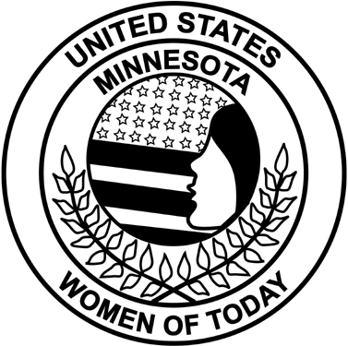
Minnesota Women of Today

Personal Enrichment Program Course Outline
PLEASE TYPE OR PRINT - Personal Enrichment Program (PEP) course manual topics that are not available through the Minnesota Women of Today State Store must be approved prior to PEP course certification. Complete the following outline form and submit it to the Living and Learning state program manager. She, along with the internal vice president, will determine if the submitted course is suitable for the Living and Learning area. Note that PEP courses should make a change in your life and/or behavior, and should include interaction between the facilitator and participants.
Chapter District
Print Name Date
Address
Email Phone
Course Outline
I. Title
II. Purpose
III. Time Frame
IV. Goals
V. Materials Used
VI. Activities and/or Exercises Used
VII. Course Evaluation

