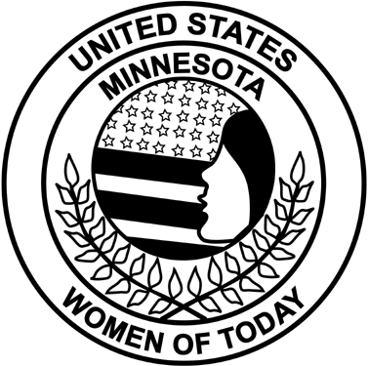
Minnesota Women of Today

Personal Enrichment Program Certification

PLEASE TYPE OR PRINT - Personal Enrichment Programs (PEP) course manual topics that are not available through the Minnesota Women of Today State Store must be approved prior to PEP course certification. See PEP Course Outline form for more information. Mail to the Living and Learning state program manager as soon as certifications are completed. No substantiating materials needed.
Chapter District
Print LPM Name Date
LPM Address
LPM Email LPM Phone
Title of Personal Enrichment Course
Date(s) Ran Length of Program
Brief explanation what was done.
Participants' Names (Please type or print very clearly)
1.
2.
3.
4.
5.
6.
7.
8.
9.
10.
11.
12.
13.
14.
15.
16.
Signature - Local Program Manager
Signature - Local Chapter President ____________________________________________________________

