How to Use your MNWT Email

Access MNWT Email Account

Change Password

Email Signature

Global Address Book

Distribution Lists

E-mail Management

E-mail Issues

MNWT Exec Council Email Addresses

MNWT Foundation and Statewide Committee Email Addresses

In an effort to maintain a professional image and eliminate confusion with email updates as leadership changes, Minnesota Women of Today has created email accounts for your use. Another positive aspect is that when there is communication with entities outside of our organization, the contact information and conversation threads can be easily passed along to the next person by simply providing them access to this email account.

1. All email shall be conducted and maintained via the designated webmail address access (position@mnwt.org). Executive Council members should not use personal email addresses for official MNWT business.
2. If a position is OPEN, the supervisor for those positions should log into and address emails in the open position accounts.
3. Misaddressed email is directed to a catch-all mnwt.org email box that is monitored by the Executive Director.

It is desired that all communication to/from your MNWT email account is maintained within the mail.mnwt.org domain and not forwarded to your personal address. This provides consistency in maintaining communication threads and eliminating use of personal email addresses which change each year. It also reduces the potential for SPAM. Using webmail also provides you access 24/7 on any device where Internet access is available.

There is an online help resource link on the lower right-hand side of the Network Solutions email login page.

**These email accounts belong to the organization. Please do NOT personalize them in any way!**

* **Do NOT enter your cell phone number/personal email for verification purposes.**
* **Do NOT change the password.**
* **Do NOT edit personal information.**
* **DO create a personalized email signature.**
* **DO use official distribution lists to send emails to specific groups (distribution lists will be updated by MNJOTS).**
* **DO use the current year folder to organize your emails throughout this year.**

## 

## Access MNWT Email Account

* Site: mail.mnwt.org
* Login: [YourPositionAcronym]@mnwt.org
* Initial password: will be given to you personally

**back to to**

## Change Password

You are encouraged to NOT change your password for security reasons. Contact Executive Director if you need your Password reset.

Passwords will be reset to a generic password at Annual Awards Special Exec for email access to incoming leaders. Please forward any email clearly intended for the previous leader of your position.

Do not set any security questions!!

**back to top**

## Email Signature

You are encouraged to use a signature line that contains your name, your MNWT position, email address, and a contact phone number.

* Click on “Configuration” icon 
* Choose “Settings” option
* Expand “Mail” option, choose “Signatures”
* Choose “Add New Signature” option
* In *Signature Name:* textbox, type your name.
* Enter contact info in the large textbox area (*Use Shift+Enter for single spacing*)
  + Name
  + Exec Council Position
  + Phone number (*optional*)
  + Email address ([*position@mnwt.org*](mailto:position@mnwt.org))
* Change "Add signature below quoted text" to "Add signature above quoted text", click “Save”
* Select *“Default Signature for new messages”* drop down box and choose your signature
* Select “*Default Signature for replies or forwardings*” drop down box and choose your signature
* Remove other signature blocks if needed by selecting the “*delete*” icon  to the right of the signature

**back to top**

## Global Address Book

Executive Council email addresses have been added to your account into a Global Address Book *(located in Public Folders)* and are maintained by the organization. When entering an address into a new email, autocomplete will provide the full address you are typing.

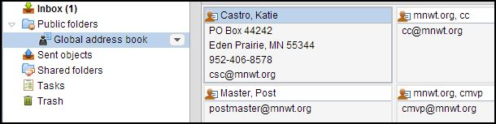

**back to top**

## Distribution Lists

Distribution lists (groups) have been set up in the Address Book under Collected addresses for Exec Council members and main committee chairs. By using these distribution lists within the Network Solutions accounts, you should not experience email delivery issues.

These lists (groups) are set up for Executive Council members’ use only and are not intended to be shared with general membership. Using these groups eliminates the need for you to create your own email group and ensures those who should receive the emails do as leadership changes happen.Those receiving the emails in the groups include:

* **All Chapters**
* **District 1-9** (Chapters grouped by district, csc, avp)
* **Area 1-4** (Chapters grouped by area, csc, avp, respective DDs)
* **Committees**: cob, csc, fdc, foundation, keywomen, marketing, mmc
* **DDs**: avp, dd02, dd03, dd04, dd05, dd06, dd07, dd08, dd09
* **Programming Team**: pvp, cc, ll, priority-area, ww, yt
* **Staff**: avp, cmvp, cob, csc, extensions, mvp, pa, parli, president, pvp, secretary, fvp, mkvp
* **Exec_Council**: all positions on Exec Council
* **Foundation Subcommittees:** foundation-chaptergrants, foundation-corporategrants, foundation-endowment, foundation-pastchair, foundation-plannedgiving, foundation-scholarships, foundation-secretary, foundation-treasurer, foundation-vicechair, foundation, cob, csc
* **Future Direction Subcommittees:** fdc-awards, fdc-chapterstructure, fdc-conventionreview, fdc-international, fdc-gogreen, fdc-manualreview, fdc-online, fdc-pastchair, fdc-restructuring, fdc-strategicplan, fdc-train, fdc, cob, csc
* **Marketing Subcommittees:** mktg-expo, , mktg-pastchair, mktg-promotions, mktg-socialmedia, mktg-statewideproject, cob, csc, web team
  + **Website Subcommittee:** cob, csc, marketing, mktg-socialmedia, president, web team
  + **Web Team:** csc, webassistant, webmaster, webhelper
* **Membership Management Subcommittees:** mmc-2020, mmc-leadership, mmc-pastchair, mmc, cob, csc

Some position holders may desire to create their own distribution lists. For example, District Directors might create a distribution list for district chapter presidents, district board, etc. If a personalized distribution list exists, you can “Edit” the current list. Do not edit the MNWT official distribution lists as changes to the official lists are made by the web team. To create your own distribution list:

* New Contacts - Enter email information into your Contacts.
  + Click on “Address Book”
  + Click on “Contacts”
  + Click “New/Add Contact”
  + Enter contact information
  + Click “Save”
* New Distribution List
  + Click on “Address Book”
  + Click on “Contacts”
  + Click “New/Add Distribution List”
  + Type “Name” of the Distribution List, it is recommended you add the current year to the name; for example: D5 Chapter Presidents 20##-##.
  + Click “Add Contact” textbox, type the address (*Note: if the address is in the Global Address book, an address will be provided you can select*), press Enter
  + Click “Create List” when done.
  + You can edit the distribution list by selecting the list and clicking “Edit” in the top menu bar.

**back to top**

## E-mail Management

At year-end, access to your position e-mail account will be transferred to the incoming officer and the password will be changed for the new year. By practicing good e-mail management throughout the year, you will eliminate the need to purge all emails at year-end which may result in valuable information being lost and not shared with the new leader. Here are some items to periodically review (*recommend monthly, trimester, or more often*):

* Check status of e-mail storage (*located in lower left corner of left panel*). Each mailbox has .98 GB of storage. This may quickly fill up if large files are attached, such as videos or pictures, or you receive several attachments multiple times throughout the year.
* Delete unneeded messages and related attachments. If there is need to save the attachments from year to year, please save them to your position’s Google Drive so that they are carried over year to year.
* Create contacts for external contacts that may be useful for future leaders in your position, then delete the unneeded emails.
* Create folders within the current year folder in the left panel and move email messages into those folders to easily locate related messages.
* Regularly check and delete items from your SPAM folder. [Handling SPAM](http://www.networksolutions.com/support/how-to-report-spam-2/) (*click link for info*)
  + You may find information in your SPAM folder that is relevant to your position for the year.
  + Add email addresses to your “Safe List” if you find you are not receiving emails
  + Add email addresses to your “Block List” for those that are SPAM
* Regularly empty your Trash folder.
* After email access has been transferred to the new incoming leader, the new leader is responsible to forward any email clearly intended for the previous position holder.

**back to top**

## 

## Auto Forward

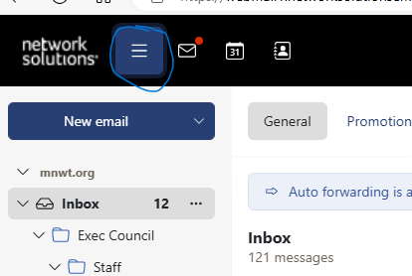

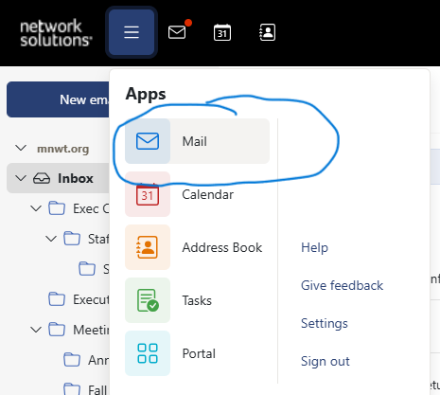

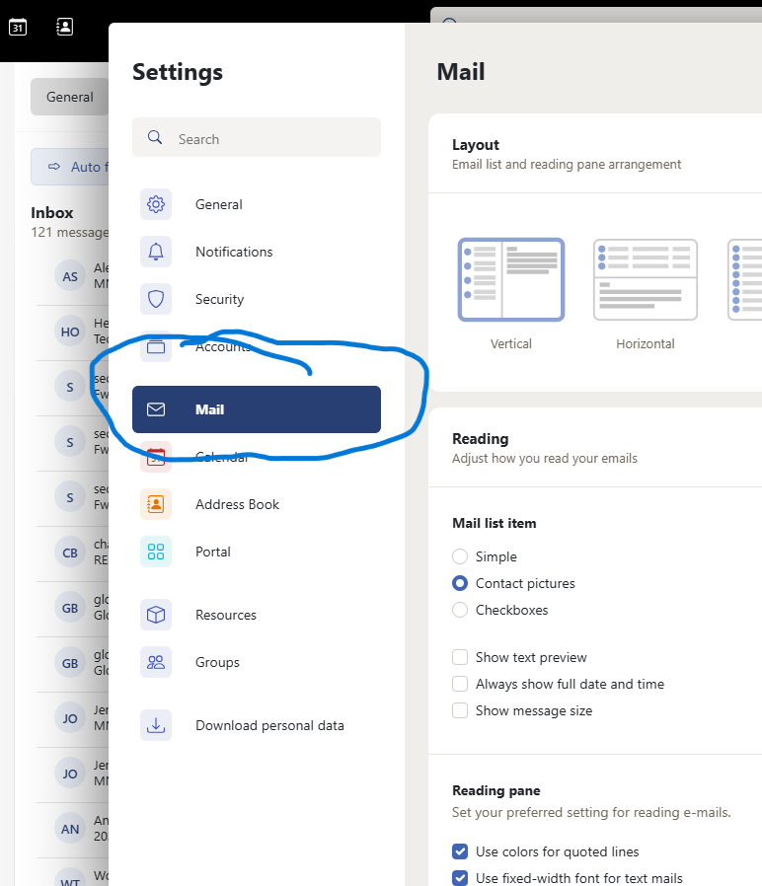

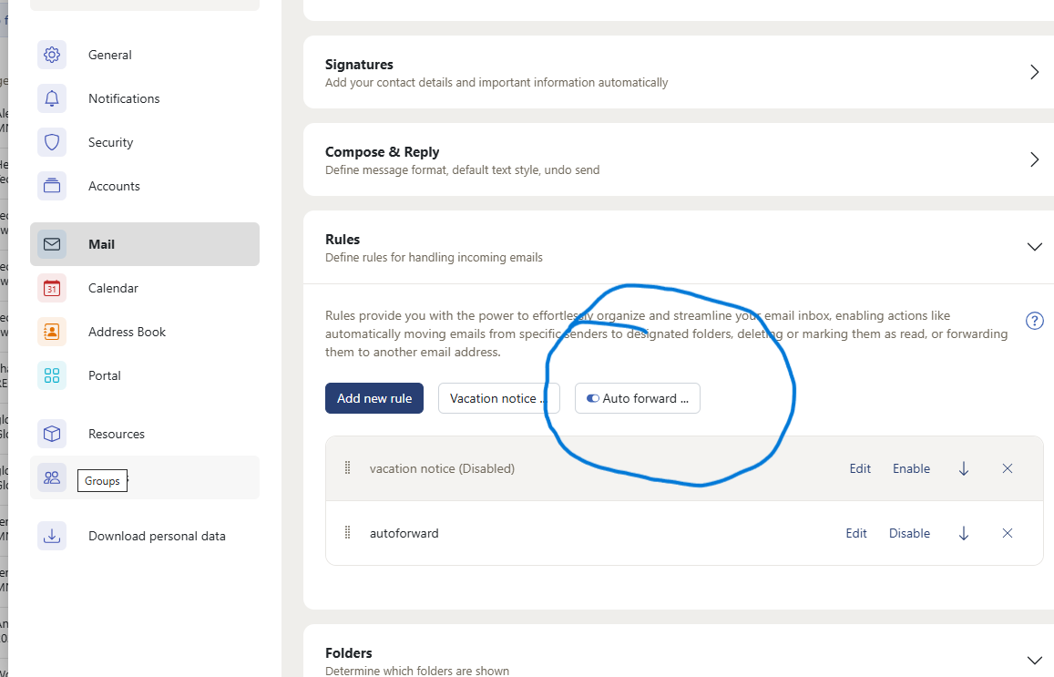

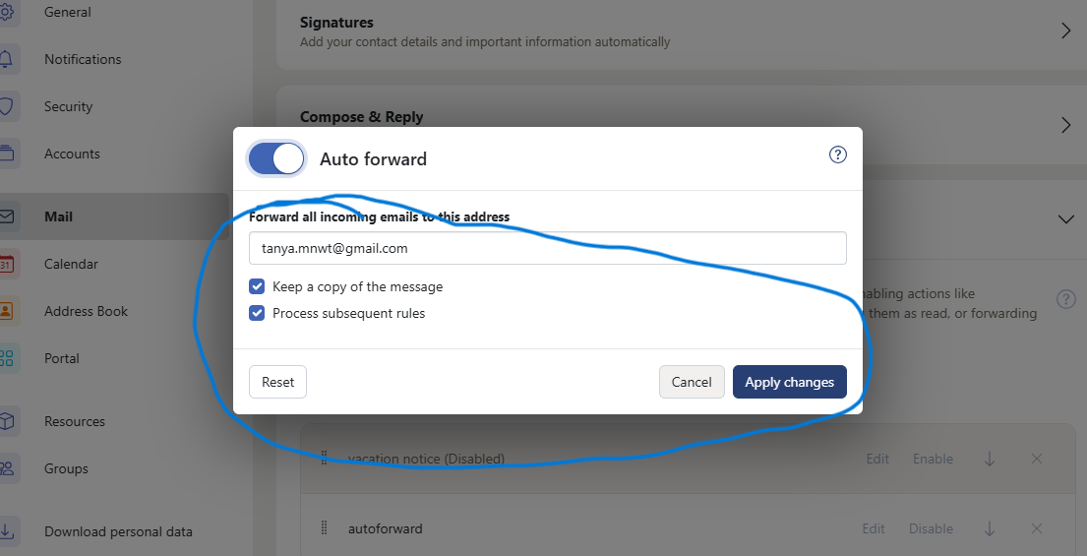

## E-mail Issues

Report issues you are having with your MNWT email by completing the [**MNWT Email Issue Form**](https://docs.google.com/forms/d/1a4OSaq1_4sQIz0akFYUUDdiKvQaREpqGgVs-seYNn0g/viewform?usp=send_form) which is found on EC Only Webpage.

## [MNWT Exec Council Email Addresses](https://docs.google.com/document/d/1U8bdtjz61yNW_7H1eDQewaDM_VJjFlXDHAsP2K1AIls/edit?usp=sharing)

## [MNWT Foundation and Statewide Committee Email Addresses](https://docs.google.com/document/d/1zAbAb3Kg33waXIpsvxyFX_NEB_7-MOUYW0jtBIB8UfI/edit?usp=sharing)

## [MNWT Chapter Email Addresses](https://docs.google.com/document/d/1AG8wO1_3GHeoxkiHjHW5Usvv8ATQz8Zi4eqPgfHeQYE/edit?usp=sharing)

**back to top**